**DECISION TREE REGRESSOR**

**INTUITION**

Suppose we have drug for a fever but we don’t know how much dosage will be effective

If the graph of drug look like this means linearly growth it is very easy to predict the how much effect data will give. Like this

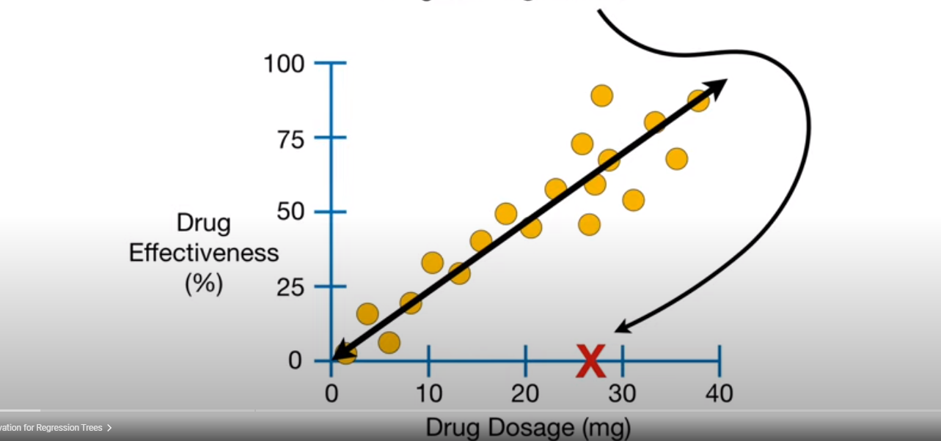

But what if this is the case:

In this case we don’t have linear growth you can see low dosages don’t giving good results , moderate dosages give good results , mid high dosages working 50% and some high dosages not effecting well. In this case if we predict using linear regression it will give false results.

So we use Decision tree or regressor tree as it predicts the data effectively in tree structure

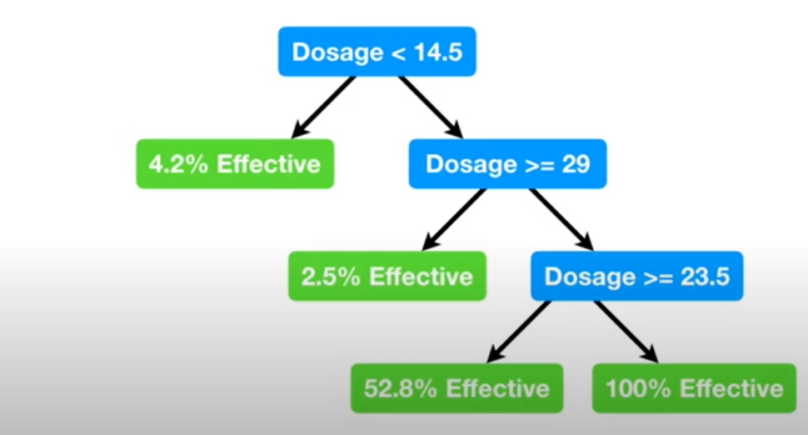

On the left hand side we have a predictive value and right hand side we have a predictor column or parameter.